Māori Digital Technology Development Fund

Stage 1 Application Form

Applications close 12 noon, Friday 9 March 2018

Instructions

- Please register your interest for this round by Wednesday 7 March 2018. Instructions for that process are contained on our website.
- This application form comprises three sections and you must complete them all. Please complete each section in the boxes provided.
Section two: Ka Hao funding flowchart
- Please use the flowchart on page 3 to help establish if this is the right fund for your initiative.
Page limits
- The applicant details and a short kōrero about your organisation should take one page.
- Completing section two should take two pages, including page 4.
- Well-articulated answers to the five questions in section three should take two pages, and definitely no more than three pages.
- If your answers to the five questions exceed the three pages, the EAG has discretion to decide how much of the additional written material will be considered. In the interests of fairness to others who stick to the three page limit, they may choose to disregard anything longer than three pages.
Supporting video
- If you submit a video to support your written application, the video must be no longer than 3 minutes. Further information and tips about recording your video are available on the Te Puni Kōkiri website – Tips for recording video
If you have any questions, please contact:

Malcolm Morrison (Programme Manager): 027 337 3727
Email: kahao@tpk.govt.nz
Website: www.tpk.govt.nz/kahao
Privacy Act
Te Puni Kōkiri is required to comply with the provisions of the Privacy Act 1993. Equally, organisations collecting personal information on behalf of Te Puni Kōkiri will comply with the provisions of the Privacy Act 1993.
Te Puni Kōkiri requires the personal information requested in this document to assess and process your funding application. We will use the information for this purpose only.
You have the right to ask for a copy of any personal information we hold about you, and to ask for it to be corrected if you think it is wrong.
For a copy of your information, or to have it corrected please contact us at Te Puni Kōkiri PO Box 3943 Wellington.

Section 1: Applicant information

Who are you?
Registered name
Address
Postal address
Phone | Landline
 | Mobile
Email
Type of organisation
Contact person

Kōrero background
Please provide a brief summary:
Applying as an individual: about yourself and your experience
Applying as an organisation: of your organisation, when it was formed, and the activities your organisation currently undertakes.
[Insert answer here]

Section 2: Ka Hao alignment questions

The two checklist questions below are designed to help you work out if your proposed project aligns to the fundamental criteria of the Māori Digital Technology Development Fund. Have a look at the flowchart below and then try to answer these in less than three sentences.

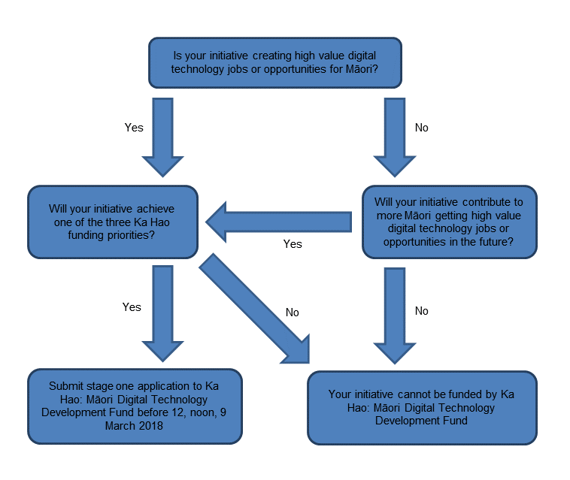

- Describe the high value jobs or opportunities your initiative will create.
Helpful hint: If the jobs you are creating are not in digital technology, this is not the right fund for you.
[Insert answer here]

- Which one of the three funding priorities below is your initiative targeting?
Helpful hint: Pick the funding priority that you feel has the strongest alignment to your initiative.

- Improving digital skills and pathways for Māori into digital technologies
- Growing digital technologies businesses
- Enhancing new Māori language and culture initiatives through digital technologies
Our initiative aligns to funding priority [1, 2 or 3 – pick one and delete the rest] because [insert answer here]

Section 3: Initiative-specific questions

- What are you doing?
Please provide a high-level description of your initiative.
[Insert answer here]

- What will you achieve?
Please describe what your initiative will achieve for its Māori participants?
Helpful hint: Think about what success looks like and how will you might measure it.
Success for your initiative should contribute to getting more Māori into high value jobs and opportunities in digital technologies.
[Insert answer here]

- Why will this initiative succeed?
Please describe how you will ensure that your team has the right skills to successfully deliver your initiative.
[Insert answer here]

- Timeframe?
Please describe how long it will take you to deliver your initiative.
[Insert answer here]

- Indicative budget?
Please include an indicative budget for your initiative.
Helpful hint: This needs to indicate what you’re spending the money on, i.e. staff, external resource, premises, equipment etc…, but you confirm a budget in stage 2.
[Insert answer here]

